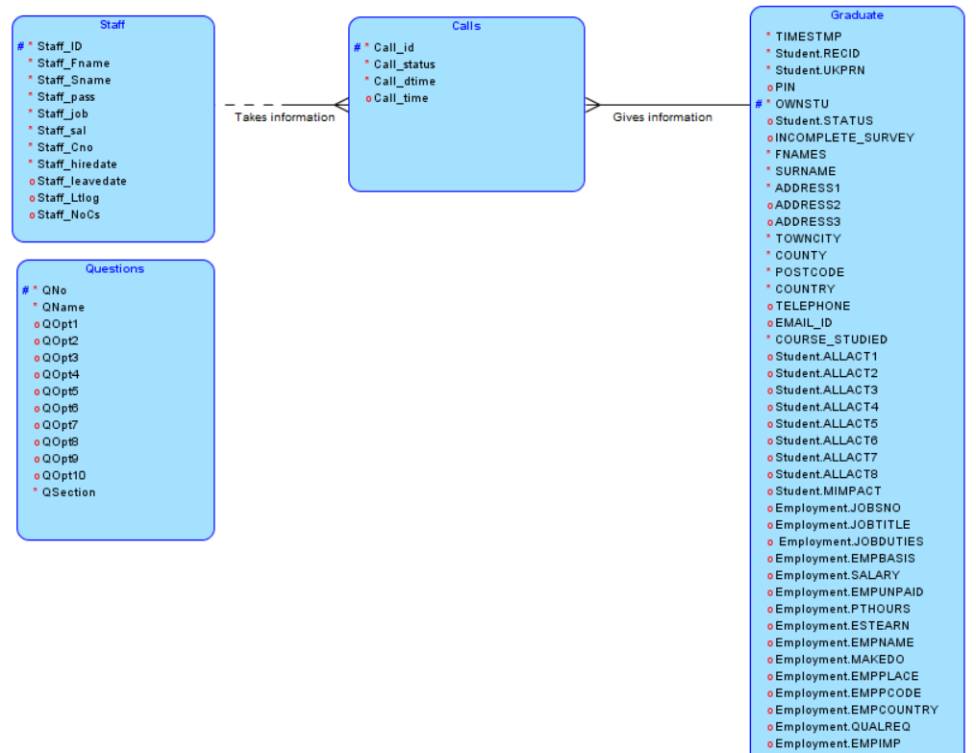Logical Model:

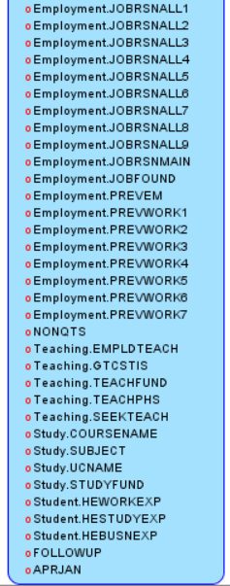

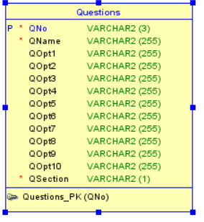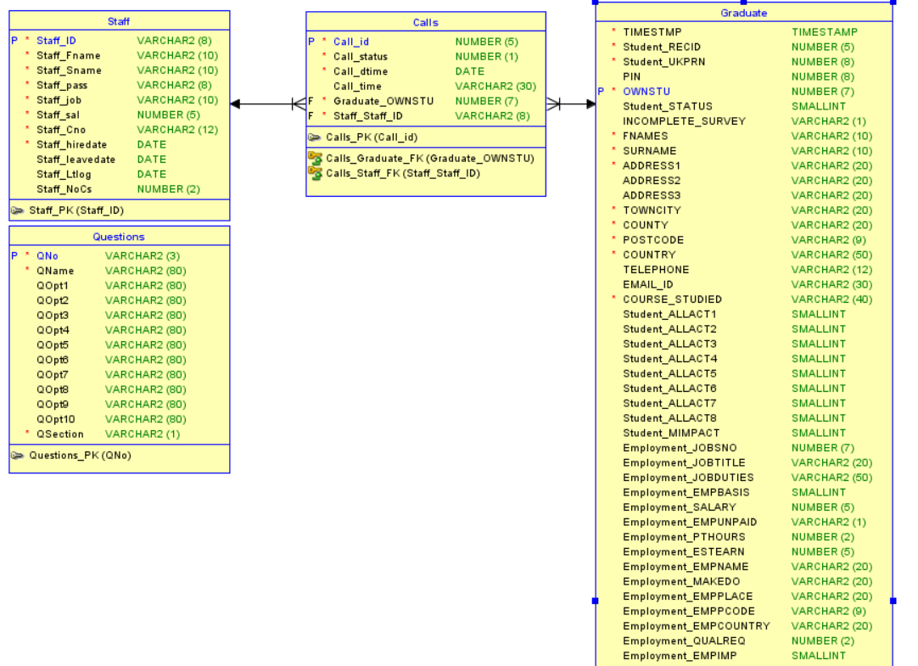Relational Model:

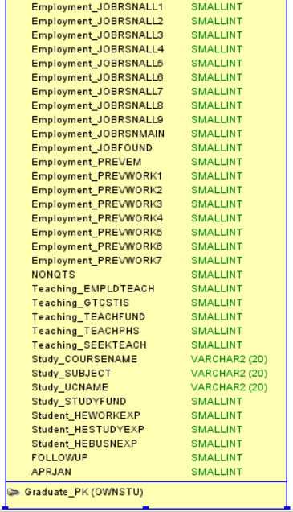

Graduate: blue = pre-populated, green = filled out by survey

* TIMESTMP: pre-populated date
* Student_RECID: automatically generated number to be pre-populated
* Student_UKPRN: automatically generated number to be pre-populated
* PIN : Unsure
* OWNSTU: Pre-populated student id, primary key of graduate table
* Student_STATUS: 2 - leaver, 3 - third party
* INCOMPLETE_SURVEY - section name when incomplete
* FNAMES - first name
* SURNAME - last name
* ADDRESS1 - address
* ADDRESS2 - other address
* ADDRESS3 - other address
* TOWNCITY - town/city
* COUNTY - county
* POSTCODE - postcode
* COUNTRY - country
* TELEPHONE - home or mobile number
* EMAIL_ID - email address
* COURSE_STUDIED - course that was studied
* Student_ALLACT1 - q1 option 1
* Student_ALLACT2 - q1 option 2
* Student_ALLACT3 - q1 option 3
* Student_ALLACT4 - q1 option 4
* Student_ALLACT5 - q1 option 5
* Student_ALLACT6 - q1 option 6
* Student_ALLACT7 - q1 option 7
* Student_ALLACT8 - q1 option 8
* Student_MIMPACT - q1 most important (radio button)
* Employment_JOBSNO - q2 how many jobs
* Employment_JOBTITLE - q3 title of job
* Employment_JOBDUTIES - q4 job duties
* Employment_EMPBASIS - q5 basis of employment (radio button)
* Employment_SALARY - q6 salary, annual pay to the nearest thousand £
* Employment_EMPUNPAID - q6 unpaid work (Y/N)
* Employment_PTHOURS - q7 part time hours
* Employment_ESTEARN - q8 estimated earnings
* Employment_EMPNAME - q9 company/organisation name
* Employment_MAKEDO - q10 what the company/organisation does
* Employment_EMPPLACE - q11 town/city/area of company/organisation
* Employment_EMPPCODE - q11 postcode of company/organisation
* Employment_EMPCOUNTRY - q11 country of company/organisation
* Employment_QUALREQ - q12 qualification requirements
* Employment_EMPIMP - q13 what part of your qualification was most important to employer
* Employment_JOBRSNALL1 - q14 option 1
* Employment_JOBRSNALL2 - q14 option 2
* Employment_JOBRSNALL3 - q14 option 3
* Employment_JOBRSNALL4 - q14 option 4
* Employment_JOBRSNALL5 - q14 option 5
* Employment_JOBRSNALL6 - q14 option 6
* Employment_JOBRSNALL7 - q14 option 7
* Employment_JOBRSNALL8 - q14 option 8
* Employment_JOBRSNALL9 - q14 option 9
* Employment_JOBRSNMAIN - q14 main reason (radio button)
* Employment_JOBFOUND - q15 how you found the job
* Employment_PREVEM - q16 did you work for the employer before/during studies
* Employment_PREVWORK1 - q17 how did you work for previous employer option 1
* Employment_PREVWORK2 - q17 how did you work for previous employer option 2
* Employment_PREVWORK3 - q17 how did you work for previous employer option 3
* Employment_PREVWORK4 - q17 how did you work for previous employer option 4
* Employment_PREVWORK5 - q17 how did you work for previous employer option 5
* Employment_PREVWORK6 - q17 how did you work for previous employer option 6
* Employment_PREVWORK7 - q17 how did you work for previous employer option 7
* NONQTS - q18 will you be employed as a teacher
* Teaching.EMPLDTEACH - q19 employed through GTC Scotland teacher induction scheme
* Teaching.GTCSTIS - q20 teaching in state funded or non state funded school/college
* Teaching.TEACHFUND - q21 teaching primary, secondary, college, educational establishment
* Teaching.TEACHPHS - q22 seeking a teaching post
* Teaching.SEEKTEACH - q23 how many registered courses are you on
* Study.TYPEQUAL - q24 what qualification are you aiming for
* Study.COURSENAME - q25 name of the course
* Study.SUBJECT - q26 subject you will be studying
* Study.UCNAME - q27 name of university/college
* Study.STUDYFUND - q28 how you will be funding
* Student.HEWORKEXP - q29 overall experience in higher education employment preparation
* Student.HESTUDYEXP - q30 overall experience in higher education further study preparation
* Student.HEBUSNEXP - q31 overall experience in higher education self-employed preparation
* FOLLOWUP - need a follow up call?
* APRJAN - when survey took place April/January

Calls:

* Call_id - primary key
* Call_status - Whether a call has been made yet (0 no, 1 yes)
* Call_dtime - The date the call was allocated
* Call_time - The amount of time the call took
* OWNSTU - foreign key
* Staff_ID - foreign key

Staff:

* Staff_ID - Primary Key
* Staff_Fname - Staff first name
* Staff_Sname - Staff surname
* Staff_pass - Staff password
* Staff_job - Staff job
* Staff_sal - Staff salary
* Staff_Cno - Staff contact number
* Staff_hiredate - When staff was hired
* Staff_leavedate - When staff left
* Staff_Ltlog- When staff last logged in
* Staff_NoCs - Staffs allocated number of call for that day

Questions:

* QNo - primary key
* QName - the questions text
* QOpt1 - option one
* QOpt2 - option two
* QOpt3 - option three
* QOpt4 - option four
* QOpt5 - option five
* QOpt6 - option six
* QOpt7 - option seven
* QOpt8 - option eight
* QOpt9 - option nine
* QOpt10 - option ten
* QSection - name of the questions section